Assignment 04

linux os & scripting – b keerthana

AMRUTHESH

241059041

M.E – Cyber Security

MSIS, MANIPAL

1. **Write a shell script to get the pattern and filename from the user, and check if the pattern exists. If the pattern exists, print the relevant message; if not, print the relevant message.**

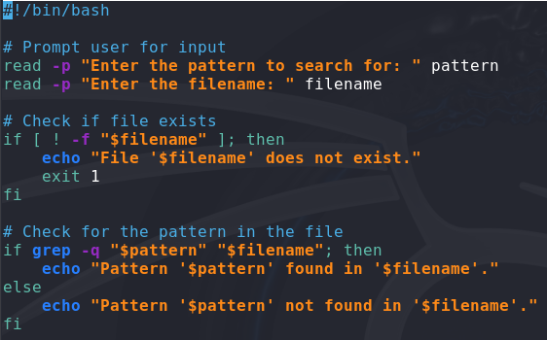 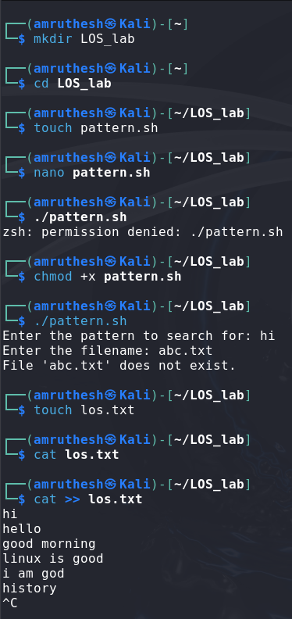

 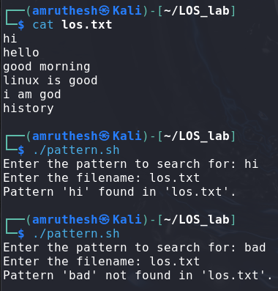

1. **Modify the above script to accept arguments from command line.**

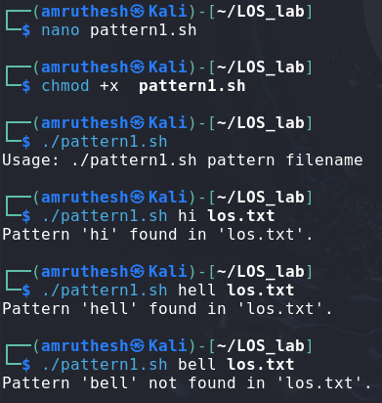 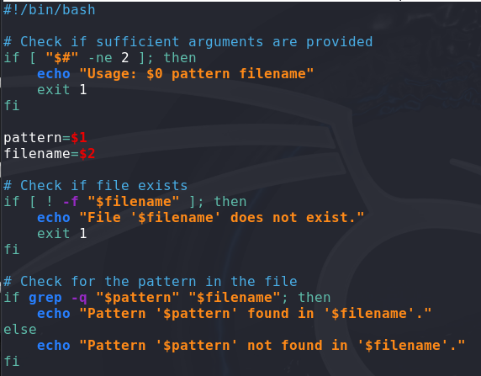

1. **Modify the above script to use hardcoded values within the script.**

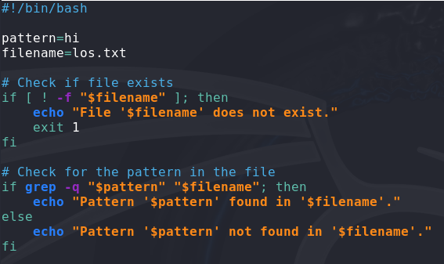

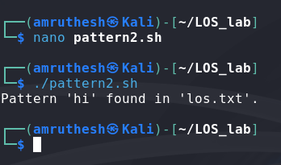

**5. Apply grep commands**

**Note: Make sure to use the options -e -c -n -q -s -f -A -B -C -i -h, -l -o -w**

**Frame the questions (as per your choice), to extract user information, to extract network information, to extract login details.**

**1. Extract User Information**

**Question: How can I find the username "amruthesh" in the user list?**

grep "amruthesh" /etc/passwd

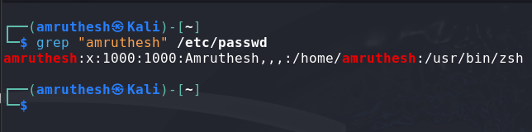

**2. Count the Number of Users Named "bob"**

**Question: How many times does "bob" appear in the user list?**

grep -c "bob" /etc/passwd

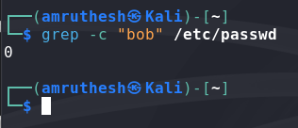

**3. Extract Network Information**

**Question: How can I find lines with "eth0" in the network configuration?**

grep "eth0" /etc/network/interfaces

**4. Extract Login Details**

**Question: How can I check for failed login attempts in the auth log?**

grep "Failed password" /var/log/auth.log

**5. Check for the Word "error" in Log Files**

**Question: Which log files contain the word "error"?**

grep -l "error" /var/log/*Bottom of Form